\t tab\n space .removeprefix() Deleteprefix .square=[value**2 for value in range(1,n)] Create nested list matrix = [list(map(int, input().split())) for _ in range(5)] list[sth]output sth’s index
STRING SLICING
s = "abcdefgh" s[3:6]=def s[3:6:2]=df s[::-1]=hgfedcba s[4:1:-2]=ec If there are spaces in the string, the spaces will occupy positions when slicing. s=”ABC d3f” s[4:0:-1]=”d CB” When using join() on a string, first convert to a list print(“ “.join([verb] * 5))
BREAK STATEMENT
mysum = 0
for i in range(5, 11, 2):
mysum += i
if mysum == 5:
break
print(mysum)
guess_and_check:quare root with while loop
guess = 0
active = False
x = int(input(“Enter a positive integer: “)
if x < 0:
active = True
while guess**2 < x:
guess = guess + 1
if guess**2 == x:
print(f”Square root of {x} is {guess}”)
else:
print(f”{x} is not a perfect square”)
if active:
print(f“Just checking…did you mean {x} ?”)
cube root（NEGATIVE INTERGER）
cube = int(input("Enter an integer: ")) for guess in range(abs(cube)+1):
if guess**3>=abs(cube):
break
if guess**3 != abs(cube):
print(cube,"is not a perfect cube")
else:
if cube < 0:
guess = -guess
print("Cube root of"+str(cube)+"is"+str(guess))
FROM INT_DECIMAL TO BINARY
if num < 0:
is_neg = True
num = abs(num)
else:
is_neg = False
result = ''
if num == 0:
result = '0'
while num > 0:
result = str(num%2) + result
num = num//2
if is_neg:
result = '-' + result
FROM FRACTION TO BINARY
x =0.625
p = 0
while ((2**p)*x)%1 != 0:
print('Remainder = ' + str((2**p)*x - int((2**p)*x)))
p += 1
num = int(x*(2**p))
result = ''
if num == 0:
result = '0'
while num > 0:
result = str(num%2) + result
num = num//2
for i in range(p- len(result)):
result = '0' + result
result = result[0:-p] + '.' + result[-p:]
print('The binary representation of the decimal ' + str(x) + ' is ' + str(result))
Never use == to test floats
APPROXIMATION ALGORITHM
x = 54321
epsilon = 0.01
numGuesses = 0
guess = 0.0
increment = 0.0001# Reset smaller increment means more values will be checked but Program will be slower
while abs(guess**2- x) >= epsilon and guess**2 <= x:
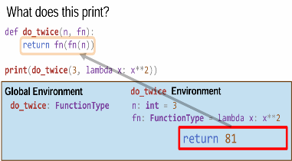
guess += increment
numGuesses += 1
print('numGuesses =', numGuesses)
if abs(guess**2- x) >= epsilon:
print('Failed on square root of', x)
else:
print(guess, 'is close to square root of', x)
BISECTION SEARCH
x = 54321
epsilon = 0.01
num_guesses = 0
if x >= 1:
low = 1.0
high = x
else:
low = x
high = 1.0
guess = (high + low)/2.0
while abs(guess**2- x) >= epsilon:
if guess**2 < x :
low = guess
else:
high = guess
guess = (high + low)/2.0
num_guesses += 1
print('num_guesses =', num_guesses)
print(guess, 'is close to square root of', x)
NEWTON-RAPHSON ROOT FINDER
epsilon = 0.01
k = 24.0
guess = k/2.0 woddd
num_guesses = 0
while abs(guess*guess - k) >= epsilon:
num_guesses += 1
guess = guess - (((guess**2) - k)/(2*guess))
print('num_guesses = ' + str(num_guesses)) print('Square root of ' + str(k) + ' is about ' + str(guess))
Positional arguments MUST follow the sequence, Keyword arguments needn’t

Inside a function, can access a variable defined outside but cannot modify a variable defined outside (can by using global variables, but frowned upon)
FUNCTION AS A PARAMETER
def calc(op, x, y):
return op(x,y)
def add(a,b):
return a+b
def div(a,b):
if b != 0:
return a/b
print("Denominator was 0.")
print(calc(add, 2, 3)) #5

def func_a():
print('inside func_a')
def func_b(y):
print('inside func_b')
return y
def func_c(f, z):
print('inside func_c')
return f(z)
print(func_a()) # inside func_a None
print(5 + func_b(2))#inside func_b 7
print(func_c(func_b, 3))#insidefunc_c insidefuc_b 3
FUNCTIONS CAN RETURN FUNCTIONS
def make_prod(a):
def g(b):
return a*b
return g
val = make_prod(2)(3)
print(val)#6
LAMBDA FUNCTIONS
apply(is_even, 10)
apply(lambda x: x%2 == 0, 10)

TUPLE INDICES AND SLICING
seq = (2, "a", 4, (1, 2))
print(len(seq)) # 4
print(seq[3]) # (1, 2)
print(seq[-1]) # (1, 2)
print(seq[-2:]) # (4, (1, 2))
print(seq[1:4:2]) # ('a', (1, 2))
print(seq[:-1]) # (2, 'a', 4)
print(seq[1:3]) # ('a', 4)
print(seq[3][0]) # 1
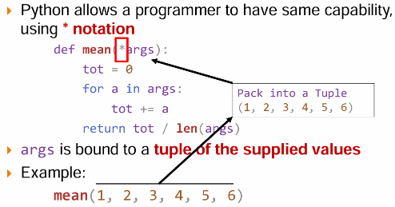

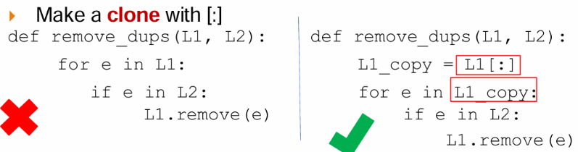

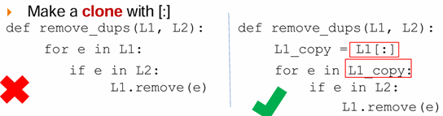
L1 = ['re'] L2 = ['mi'] L3 = ['do']
L4 = L1 + L2 #[‘re’, ‘mi’]
L3.append(L4) #[‘do’,[‘re’, ‘mi’]]
L = L1.append(L3)#None
STRING TO LISTS
s.split() no parameter:split by space
LISTS TO STRINGS
Use ''.join(L) to turn a list of strings into a bigger string
L =['a','b','c’]#LIST
A = ''.join(L) #”abc
B ='_'.join(L) #”a_b_c”
C=''.join([1,2,3]) error
C=' '.join(['1','2','3’] “a b c”
FUNCTION CAN CHANGE SEQUENCES
L=[9,6,0,3]
a = sorted(L) → returns a new sorted list, does not mutate L
b = L.sort() → mutates L to be [0,3,5,6,9] and returns None
L.reverse() → mutates L to be [9,6,5,3,0] and returns None
FIND INDEX IN LIST
Index = list.index(sth)
Print(index)
FIND ALL INDEX OF A STH IN LIST
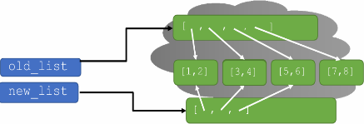
My_list = [‘a’, ‘b’, ‘a’, ‘c’]
Target = ‘a’
Indices = [i for i, x in enumerate(my_list) if x == target]
Print(indices)#[0,2]
FIND ALL INDEX OF A STH IN LIST FROM A SPECIFIC INDEX
My_list = [‘a’, ‘b’, ‘a’, ‘c’]
Index = my_list.index(‘a’,1) #2
Index = my_list.index(‘a’, 1,3)#There are two valid values, but index() will only return the first one found，namely 1
FUNCTION EXTEND
Append all elements from another sequence (list, tuple, string, etc.) to the end of the list (unpacking only one level)
numbers = [1, 2, 3]
numbers.extend([4, 5])
print(numbers) # [1, 2, 3, 4, 5]
chars = ['a', 'b']
chars.extend('hello')
print(chars) #['a', 'b', 'h', 'e', 'l', 'l', 'o']
empty_list = []
empty_list.extend([1, 2, 3])
print(empty_list) # [1, 2, 3]
L2 = [4,5,6]
L2.extend([[1,2],[3,4]])# [4,5,6,[1,2],[3,4]]
REMOVE ALL ELEMENTS IN A LIST
List.clear()#Doesn’t make a new empty list
OPERATION ON LISTS: remove
L = [2,1,3,6,3,7,0]
L.remove(2)#[1,3,6,3,7,0]
Lremove(3)#[2,1,6,3,7,0]
Del(L[1])#[2,3,6,3,7,0]
A = L.pop()#a=0 and L=[2,1,3,6,3,7]
EXERCISE WITH REMOVE INSTEAD OF COPY AND CLEAR（remenber elements will move to another index when loop the list!）
def remove_all(L, e):
while e in L:
L.remove(e)
MAKE A COPY OF THE LIST
Lcopy = L[:]
MUTATION AND ITERATION WITH CLONE
L1_copy = L1[:]

old_list = [[1,2],[3,4],[5,'foo']]
new_list = old_list
new_list[2][1] = 6# New list: [[1,2],[3,4],[5,6]]
Old list: [[1,2],[3,4],[5,6]](Assignment just creates a new pointer to same object)
LIST SHALLOW COPY
import copy
Old_list = [1,2,3,4]
New_list = copy.copy(Old_list) #equivalent to Lcopy = L[:]
old_list.append([7,8])#New list: [[1,2],[3,4],[5,6]], Old list: [[1,2],[3,4],[5,6],[7,8]](mutate top level structures of one doesn’t affect the clone)
old_list[1][1] = 9# New list: [[1,2],[3,9],[5,6]] Old list: [[1,2],[3,9],[5,6]](change an element in one of the sub-structures, they are shared)
Top level

Elements are aliases

LIST DEEP COPY
New_list = copy.deepcopy(old_list)
old_list[1][1] = 9# New list: [[1,2],[3,4],[5,6]] old list: [[1,2],[3,9],[5,6]]
LIST COMPREHENSION
[expression for elem in iterable if test](test is optional)
def f(L):
Lnew = []
for e in L:
if e%2 == 0:
Lnew.append(e**2)
return Lnew
is equivalent to:
Lnew = [e**2 for e in L if e%2 == 0]
Def f(expr, old_list, test = lambda x:True):
New_list = []
For e in old_list
If test(e):
New_list.append(expr(e))
Return new_list
[[e,e**2] for e in range(4) if e%2==0]#[[1,1], [3,9]]
HANDLING EXCEPTIONS
try:
# do some potentially
# problematic code
except:
# do something to
# handle the problem
def sum_digits(s):
total = 0
For char in s:
try:
val = int(char)
total += val
except:(there are nondigits)
print("can't convert", char)
return total
try:
a = int(input("Tell me one number: "))
b = int(input("Tell me another number: ")) print("a/b = ", a/b)
print("a+b = ", a+b)
except ValueError:
print("Could not convert to a number.") except ZeroDivisionError:
print("Can't divide by zero")
print("a/b = infinity")
print("a+b =", a+b)
except:
print("Something went very wrong.")
WHAT TO DO WITH EXCEPTIONS
1.fall silently
2.return an error value
3.stop execution, signal error condition(raise an exception)
def sum_digits(s):
total = 0
for char in s:
try:
val = int(char)
total += val
except:
raise ValueError("string contained a character")
ASSERTIONS
assert len(s) != 0, "s is empty
CREATING DICTIONARIES
Empty_dict={}
Empty_dict=dict()
grades = dict(math=95, science=88)

keys = ['a', 'b', 'c']
values = [1, 2, 3]
mapped = dict(zip(keys, values))

squares = {x: x*x for x in range(5)}
DICTIONARY LOOKUP
grades = {'Ana':'B', 'Matt':'A', 'John':'B', } grades['John']#’B’
grades['Grace']#KeyError
print(grades.get('Ana'))# ‘B’
print(grades.get('Kay'))# None
print(grades.get('Kay', 'Not found'))#'Not found'
DICTIONARY OPERATIONS
Add an entry grades['Grace']='A'
grades.update({'cyh': 'A', 'klein': ‘A’})
Change entry grades['Grace']='C'
Delete entry del(grades['Ana'])
key, value = grades.popitem()#(‘John’,’B’)
Test if key in dictionary
'John' in grades#True
'Daniel' in grades#False
'B' in grades#False(only test key, not value)
Get an iterable that acts like a tuple of all keys
Print(grades.keys())#dict_keys(['Ana', 'Matt', 'John'])
list(grades.keys())#return['Ana', 'Matt', 'John']
Get an iterable that acts like a tuple of all dict values
Print(grades.values()) dict_values(['B', 'A', 'B',])
list(grades.values())#returns ['B', 'A', 'B']
Get an iterable that acts like a tuple of all items
Print(g())#dict_items([('Ana', 'B'), ('Matt', 'A'), ('John', 'B')])
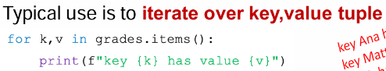
list(grades.items())#returns [('Ana', 'B'), ('Matt', 'A'), ('John', 'B')]

CREATING A DICTIONARY
song="RAH RAH AH AH AH ROM MAH RO MAH MAH"
def generate_word_dict(song): song_words=song.lower() words_list=song_words.split() word_dict={}
for w in words_list:
if w in word_dict:
word_dict[w]+=1
else:
word_dict[w]=1
return word_dict#word_dict = {'rah':2, 'ah':3, 'rom':1, 'mah':3, 'ro':1}

def find_frequent_word(word_dict):
words = []
highest = max(word_dict.values())
for k,v in word_dict.items():
if v == highest:
words.append(k)
return (words, highest)#([‘ah’,’mah’],3）
def occurs_often(word_dict,x):
freq_list=[] word_freq_tuple=find_frequent_word(word_dict)
while word_freq_tuple[1]>x: freq_list.append(word_freq_tuple) for word in word_freq_tuple[0]:
del(word_dict[word])
word_freq_tuple=find_frequent_word(word_dict)
return freq_list# [(['ah','mah'],3), (['rah'],2)]
RECURSION
Recursivestep If b != 1, a*b = a + a*(b-1) } Basecase If b = 1, a*b = a
def mult_recur(a, b):
if b == 1:
return a
else:
return a + mult_recur(a, b-1)
HOW TO UNPACKE NESTED LIST
L = [[1,2],3,4,[[5,6],[7,8]]]
Def nested(L):
New_L = []
For e in L:
If type(e) == list:
New_L.extend(nested(e))
Else:
New_L.extend(e)
Return new_L#[1,2,3,4,5,6,7,8]
REVERSE ALL ELEMENTS IN ALL SUBLISTS
def deep_rev(L):
L2 = []
for e in L[::-1]:
if type(e) == list: L2.append(deep_rev(e))
else:
L2.append(e)
return L2#[[[8,7],[6,5]],4,3,[2,1]]
FIBONACCI
Def fib(n):
If n <= 1:
Return 1
Return fib(n-1) + fib(n-2)
BINARY SEARCH-RECURISON WAY
Def binary_search(a, target, l=0, r=None):
If r is None:
r = len(a)-1
if l > r:
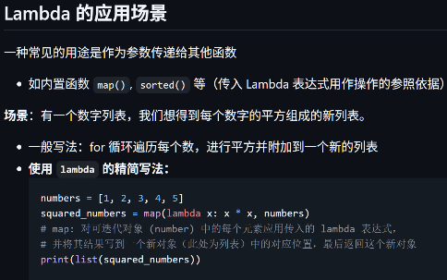
return -1
m = (l + r)//2
if a[m] == target:
return m
if a[m]<target:
return binary_search(a,target, m+1, r)
else:
return binary_search(a,target,l,m-1)
PROBLEM-lower triangular mutipulation
m = float(input())
n = int(m)
if n!=m or n<1 or n>9:
print(“Invalid”)
else:
for i in range(1, n+1):
row = ‘’
for j in range(1, i+1)
row += f”{j}x{i}={i*j:2}” + “\t”
print(row)
PROBLEM-Rhombus generator
h = int(input())
w = int(input())
c = input()
middle = h // 2
max_chars = 1+middle*w
for i in range(middle + 1):
num_chars = 1 + i*w
space = (max_chars – num_chars)//2
print(“ “*space + c*num_chars)
for i in range(middle – 1, -1, -1)
num_chars = 1 + i*w
space = (max_chars – num_chars)//2
print(“ “*space + c*num_chars)
OR:
For i in range(h):
Distance = abs(i – middle)
Num_chars = max_chars – distance*w
Space = (max_chars – num_chars)//2
Print(“ “ * space + c*num_chars)
PROBLEM-Palindromic substring counter
s = input()
n = len(s)
cnt = 0
for c in range(n):
l = r = c
while l>=0 and r<n and s[l] == s[r]:
cnt += 1
l -= 1
r += 1
for c in range(n-1):
l, r = c, c+1
while l>=0 and r<n and s[l] == s[r]:
cnt += 1
l -= 1
r += 1
print(cnt)
PROBLEM-Calculator with lambda functions
def get_op(op_name: str):
if op_name == "add":
return lambda x, y: x + y
elif op_name == "sub":
return lambda x, y: x - y
elif op_name == "mul":
return lambda x, y: x * y
elif op_name == "div":
return lambda x, y: x / y
elif op_name == "pow":
return lambda x, y: x ** y
elif op_name == "max":
return lambda x, y: x if x>=y else y
elif op_name == "min":
return lambda x, y: x if x<=y else y
def calc(op, x: float, y: float) -> float:
return op(x, y)

DICTIONARY COMPREHENSION
Transform existing dictionary
person = {'name': 'alice', 'age': '30'}
uppercase = {k: v.upper() if isinstance(v, str) else v for k, v in person.items()}#{'name': 'ALICE', 'age': '30'}
swap keys and values
original = {'a': 1, 'b': 2, 'c': 3}
swapped = {v: k for k, v in original.items()}#{1: 'a', 2: 'b', 3: 'c'}
Merging Dictionaries
dict1 = {'a': 1, 'b': 2}
dict2 = {'b': 3, 'c': 4}
merged={**dict1, **dict2}#{'a': 1, 'b': 3, 'c': 4}
dict1.update(dict2)#dict1={'a': 1, 'b': 3, 'c': 4}
Useful Dictionary Methods
defaults = dict.fromkeys(['name', 'age', 'city'], 'unknown')# {'name': 'unknown', 'age': 'unknown', 'city': 'unknown'}
if person: # True if not empty
print("Dict has items")

